“Automated Time Table Generator Project “

Team’s ID: G102

Team’s Name: EBS

Team’s Section: 5

Under the Supervision of:

* Dr.Sally Saad
* Dr.Sherin Moussa
* Dr.Yomna Kawashti

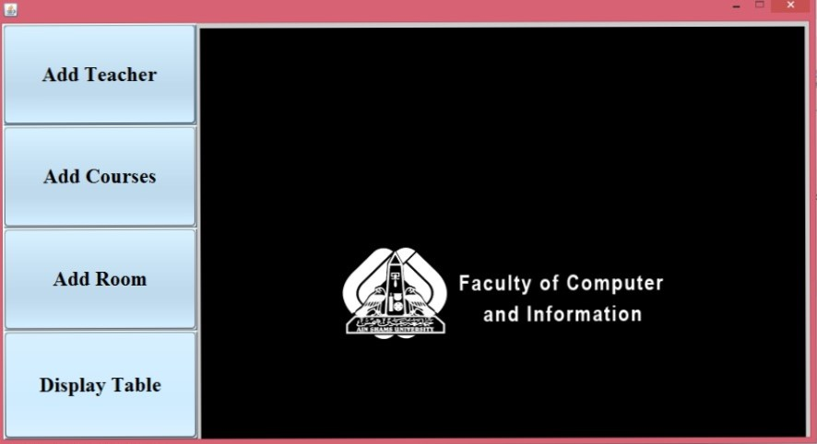 “The First Panel While Running The project”

On Clicking “Add Teacher Button “a new panel is appeared and you add new teacher information to be added in your timetable.

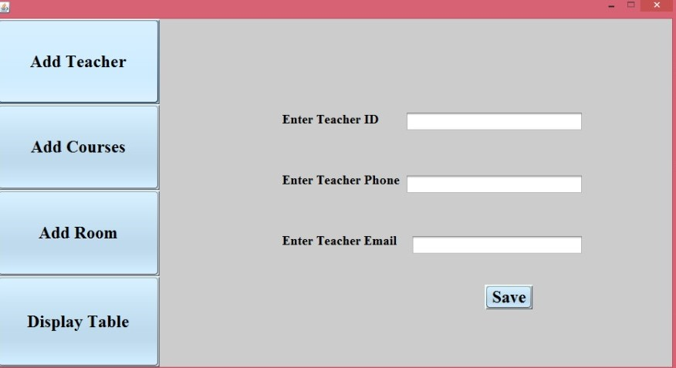

On Clicking “Add Course Button” another panel is appeared which is responsible for adding new course with all it’s information 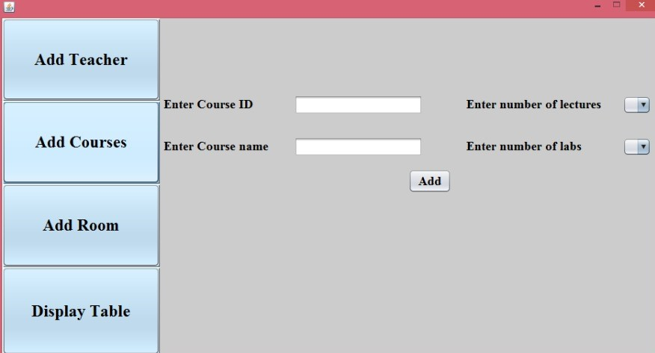.

After Enter Course ID and Course Name and choose to Enter number of Lecture of this course a new panel is appeared and you add the information of all lectures according to the number of them which you had chosen.

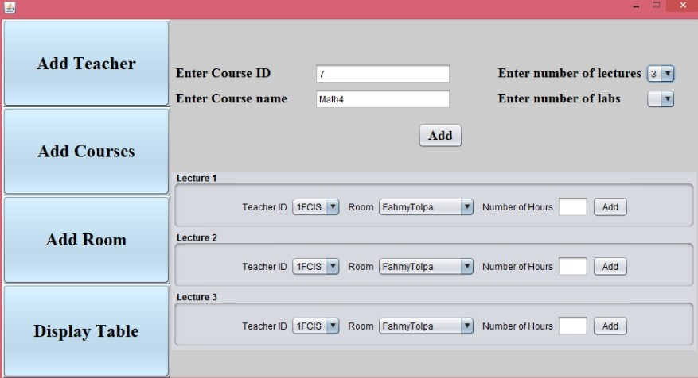

Now You choose to Enter Number of Labs, so the panel will be about labs, and you add the information of all labs of this course according to their number.

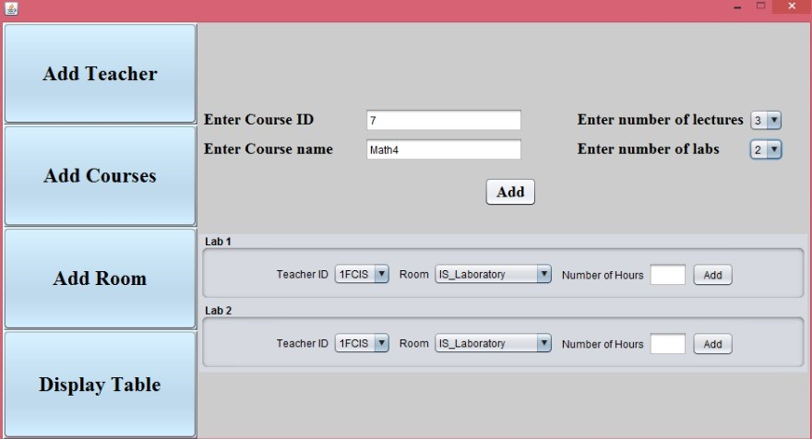

On Clicking “Add Room Button” a new panel is appeared and you Enter The number of all rooms you want to have , then another panel is appeared which contains all rooms according to the number you had Entered and the type of the room you want to add (Laboratory or Classroom) you just have to Enter the Room’s Name and select its type.

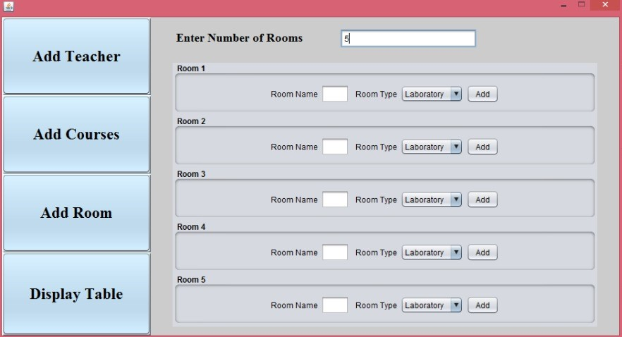

On Clicking “Display Table Button” a new panel is appeared which contains Four choices (Teacher ID – Room Name – Course Name –

The whole Time Table).

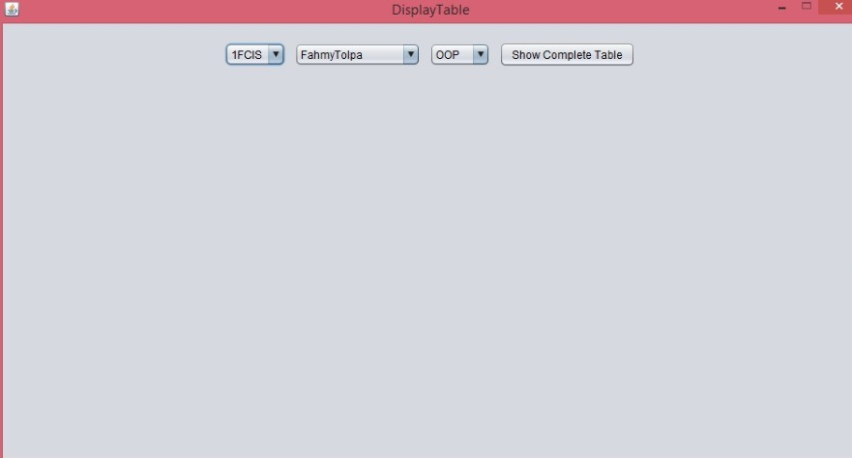

If You Choose to Display the Time Table of each teacher you have, then you got all the Teachers’ IDs, so you choose the ID of the Teacher you want his Time Table.

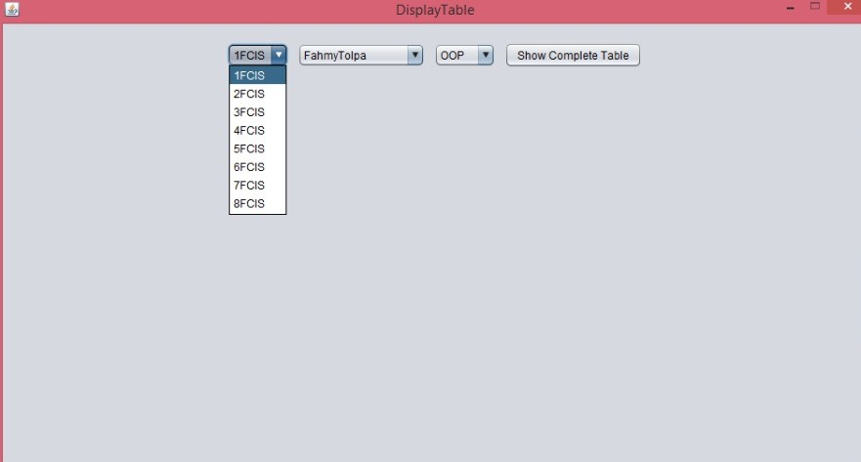

This is the Time Table of the Teacher you have selected.

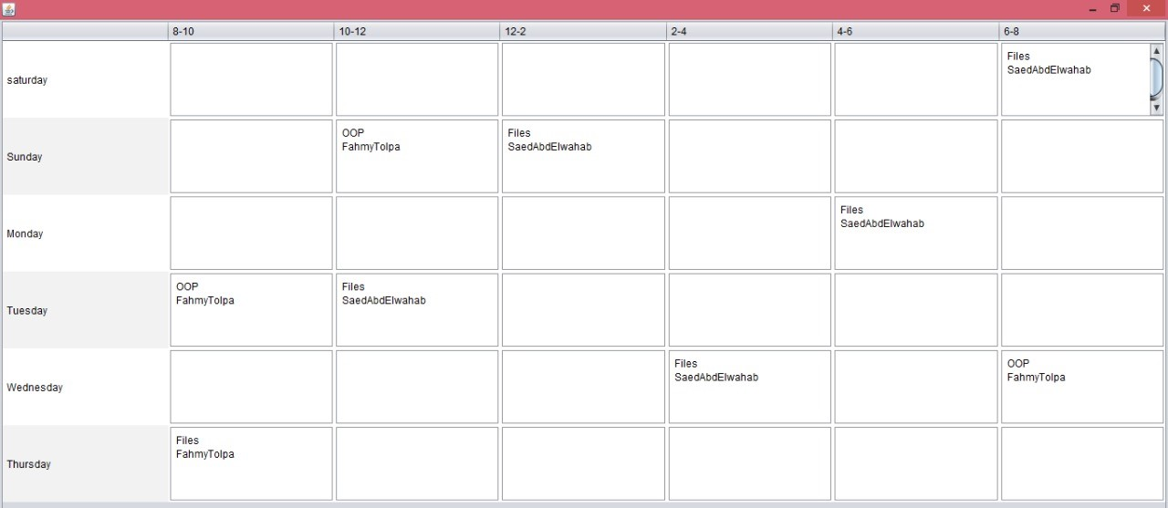

If You Choose to Display the Time Table of each Room you have, then you got all the Rooms’ Names, so you choose the Name of the Room you want It’s Time Table.

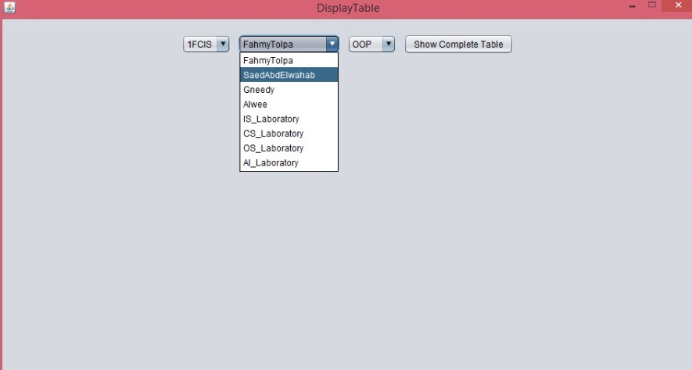

This is the Time Table of the Room you have selected.

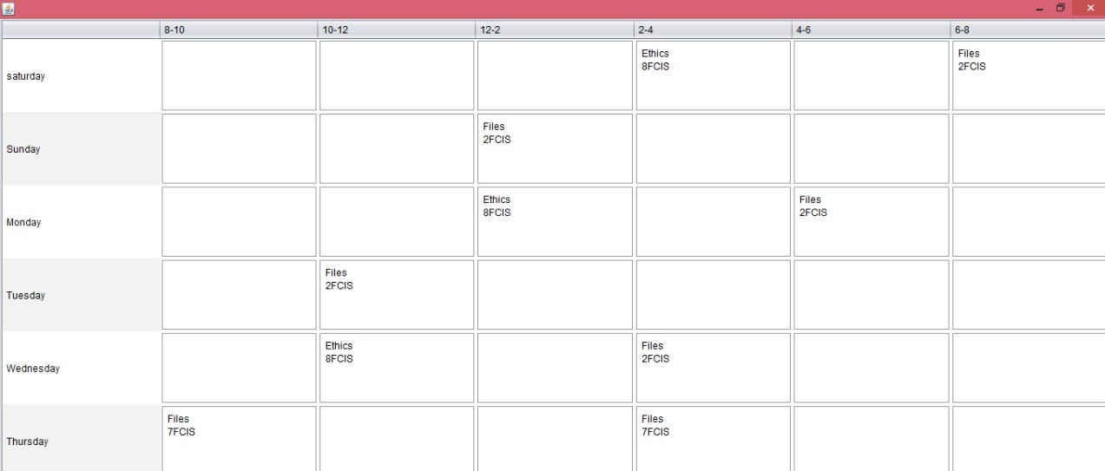

If You Choose to Display the Time Table of each Course you have, then you got all the Courses’ Names, so you choose the Name of the Course you want It’s Time Table.

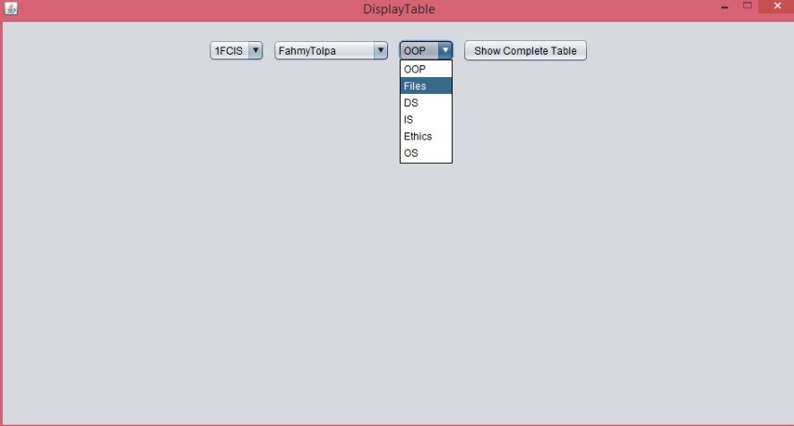

This is the Time Table of the Course you have selected.

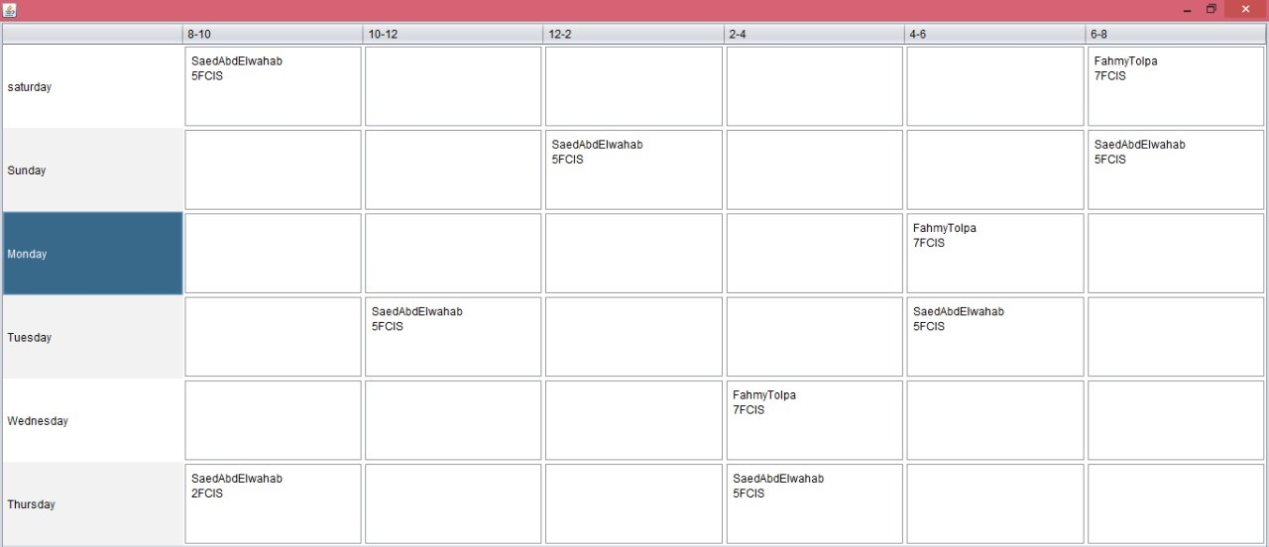

If You Want to Display the Whole Time Table with All the Information.

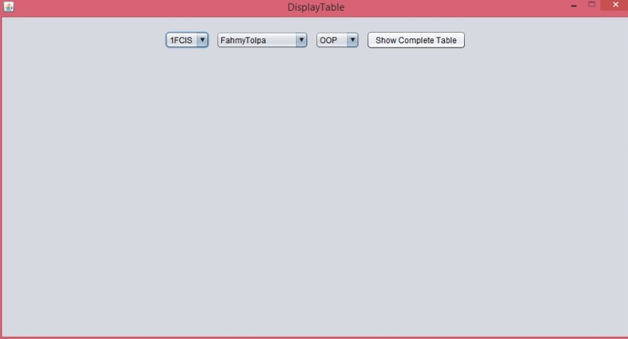

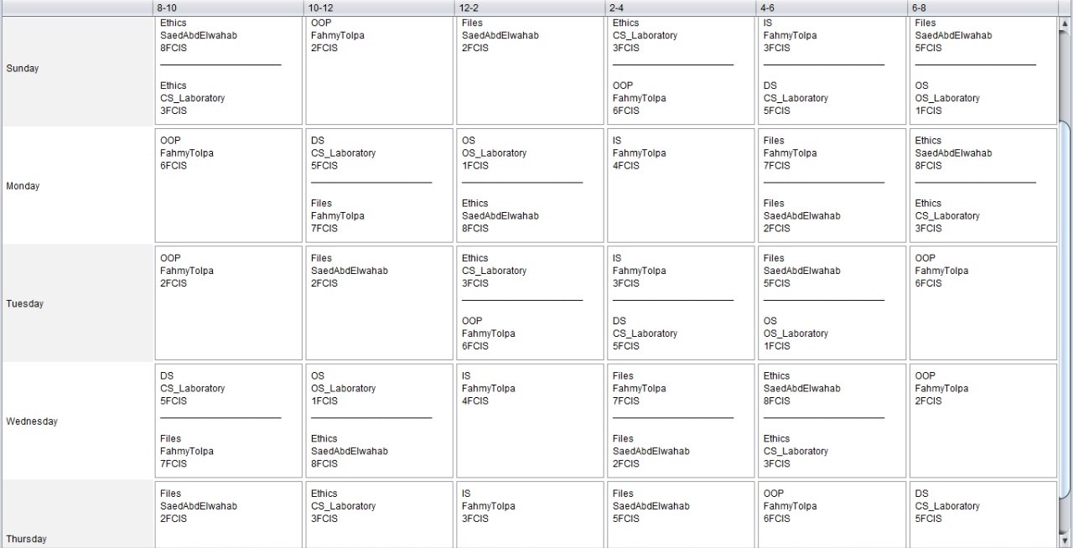 This is The Whole Time Table

YES

Click “Add Teacher” button

Save

**Enter Teacher ID , Name**

**And Email**

NO

Choose to Enter number of labs

Click “Add Course” button

**Enter the required number of labs and Details of the course**

**Enter Course ID , Name**

YES

YES

NO

**Enter the required number of lectures and Details of the course**

NO

Click “Add Room” button

NO

**Display The**

**Time Table**

Click “Display Time Table” button

**Enter Details of All**

**Selected Rooms**

**Enter Number of Rooms**

YES